

Issue no: 3
Carlton Primary Newsletter
Week Beginning: 22nd October 2012
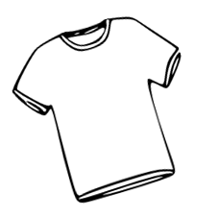




Dear Parents/Carers,
In this newsletter I have included information on a change to the start dates for children in the Spring Term – which is due to training for staff.

With half-term approaching next week, on behalf of the staff I would like to wish everyone a happy holiday. School will re-open on Monday 5th November for all children.

If you would like an electronic copy of our newsletter, then please e-mail Mia at: admin@carlton.camden.sch.uk giving your child’s name. We will be really happy to add you to the list.
If you need to speak to anyone or any member of staff please do not hesitate to make an appointment! We’re very happy to help.
Don’t let little worries become big ones!
Tuesday 6th November
9:00 – 10:30am

All parents & Carers are invited to our Eid celebration. You can come along to share a dish with each other.

Eid Coffee Morning
Jacqueline Phelan

Achievement for All

On 10th October we raised an amazing £522 for the playroom at the Whittington Hospital. Thank you to everyone who donated so generously!
In my last newsletter I mentioned that there was a new Chair and Vice Chair. As a reminder, our new Chair of Governors is Kate Jarman and the 2 new Vice Chairs are Noella Bella-Castro and Kevin Hull. They can all be contacted at the school should any parent/carer wish to speak to them.
With Eid expected at the end of this week, I would like to remind parents/carers that all children celebrating Eid are allowed one authorised day off.
On behalf of staff I would like to wish all our families Eid Mubarak!
Eid Mubarak!
Change to the Governing
Receiving Our Newsletter by E-mail
Body

On Friday 19th October Year 6 went on the School Journey for 3 days to Windmill Hill in Hailsham, East Sussex. The children had a fantastic time and they all came back safely. Here’s what some of them had to say about their trip:

“It was a very fun and amazing experience” – Hamida 6M
“It’s a very fun and wild, adventurous and inspirational experience. You do many different sports and team building stuff.” – Chris 6M
“I learned how to do many things and how to take care of myself. I enjoyed working as a team because it made us come together.” – Diana 6D

As part of the school policy;
Please ensure that your children are in uniform each day. Most of the school uniform can be purchased at school.
Please see below for the uniform available:

Sweatshirt: £7.50/8.00/8.50
Cardigan: £9.50
Polo Shirt: £6.50/7.50
P.E. T-Shirt: £3.00
P.E. Shorts: £4.00
PACT folder: £3.00

Uniform is available in sizes 3/4, 5/6, 7/8, 9/10, 11/12 & 13yrs.
A reminder: the school now has a P.E. uniform. It is a plain white t-shirt and plain black shorts or jogging bottoms.
JEWELLERY
Please remember that jewellery is not to be worn at school.
The children can only wear watches and small stud earrings.

School Uniform
The School Journey



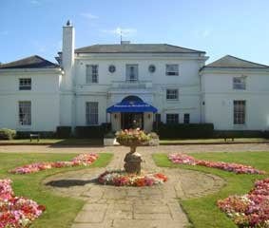
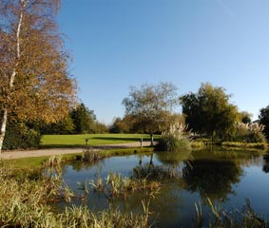
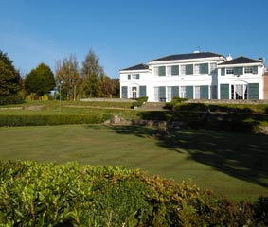
At Carlton we make sure that we use every minute of the day to help children learn.
Please ensure that your child attends school each day and is on time.
School starts at: 8.45am
School ends at: 3.30pm
Nursery ends at: 3.20pm
If you need to visit the doctor or the dentist we ask that where possible those appointments are made at the end of the day after school has finished. If this can’t be avoided then please bring an appointment card to the office! Thank you
Attendance and Punctuality
Coffee mornings
have changed
to Tuesday mornings
9 - 10.30am
All welcome!

End of Day
In order to ensure our children’s safety and complete access to the curriculum, this is a reminder to our parents/carers that the school gates will not open until 3:20pm. We ask that all parents/carers wait outside until then as the playground may be being used for P.E. or games. Children from Year 1 can now be collected at 3:25pm to ease congestion on the stairs. Thank you for your co-operation.
If your child is late please remember to sign them in the late book when they arrive!
This ensures that they are marked as being in school and ensures that they are counted in for school meals.
Late Book

